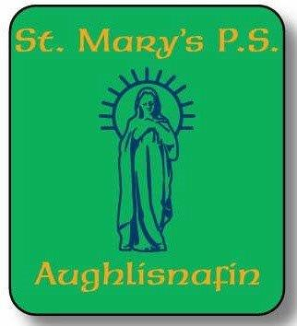
03.09.2025
Dear Parents and Guardians,
I would like to take this opportunity to commend you and the children on how well turned out the boys and girls are on their start to the new school year, and give praise to the children for their excellent manners and behaviour displayed.
Well done boys and girls.
We look forward to welcoming the younger children from Mrs Cahill’s reception class and the children from Mrs McEvoy’s class in the very near future.
Some parents have been enquiring about PE days and Outdoor Play Days*( Weather permitting)
To this end, use the following as a guide:
Classes | Tuesday | Thursday
Reception/ P1 and P2/3 | PE | PE/Outdoor Play
P4/5 and P6/7 | PE | Swimming
After schools activities begin next week, with Bee Active on Wednesday afternoon, 10th September, and Funfit on Friday afternoon, 12th September.
Kazoku Gaelic will not begin until Thursday 18th September.
The school Wraparound will be available on Mondays and Tuesdays.
Any child going to Bee Active, Gaelic or Funfit may wear the school PE gear that day.
If there is any change to the above, I will keep you informed.

Warm regards,
Peter Higgins
Acting Principal
St Mary’s Primary School, Aughlisnafin

