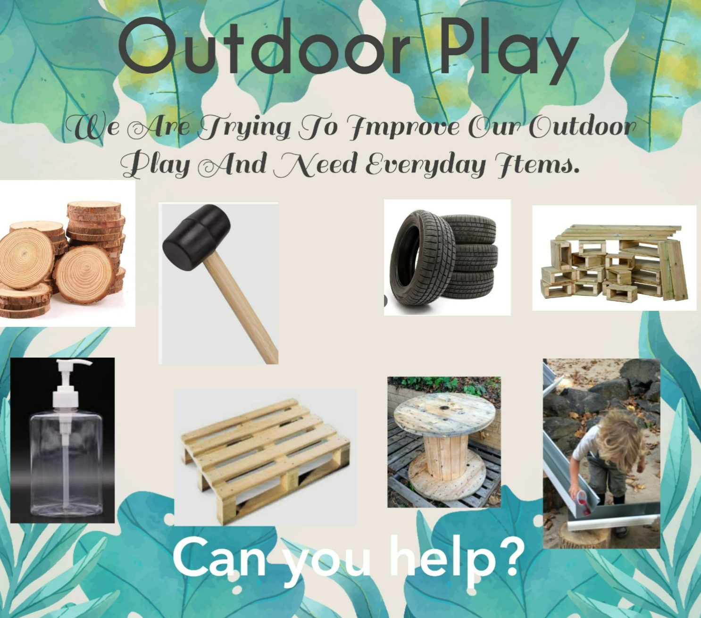

Dear Parents,

We are organising our outdoor area and are aiming to build a bank of resources. Below is a list of suggested resources we would like families/businesses to donate for our outdoor learning areas. These may be items that you have around the house/garden that you longer need. Please do not send in broken or faulty items or wood with splinters. We would really appreciate your help and support.

|  |  |  |  |  |
| --- | --- | --- | --- | --- |
| **Outdoor play Resources** | | | | |
| Bamboo sticks | drain spouts | sponges | wooden spoons | tubs for larger equipment |
| Pallets | syringes | bamboo canes | whisks | tarp |
| Tyres | buckets | trees stumps/logs | jugs | bungee cords |
| long planks of wood | funnels | string | trays | large plastic sheets |
| pipes | Seeds | ropes | storage | large pieces of card |
| tubs for larger equipment | various sizes pieces of wood | milk crates | large containers (more 3/5 litre) | clip boards |
| tarp | chalk | reels | ice cube trays | washing line |
| bungee cords | sieves | nails, tacks hammers | piping bags | magnifying glasses |
| large plastic sheets | water storage / water butt | masking tape | fireproof board | digging tools |
| large pieces of card | umbrellas | plastic sheets | firepit | Gardening tools |
| planks of wood | tin cups and plates | tent pegs | clothes pegs | bug boxes |
| clipboards | ladders | Vegetable trolly | paint brushes | diy tools |
| binoculars | spatulas | Pull along cart | Spoons – wooden, hard plastic or metal. | hose pipe to connect to water |
| broom handles | cake tins | dressing up clothes | hose pipe to connect to water | old hose pipe |
| cable spools | food colouring | rubber gloves | old hose pipe | storage trolly for junk art |
| elastic bands | trugs/ builder buckets | aprons | storage trolly for junk art | clay and tools |
| rolls of paper | polytunnel | old Belfast sink/bathtub/trough | bark | large drainpipes for tunnels |
| small baskets | wire cooling racks | bird boxes/tables | bricks | sieves |
| chopping boards | old keyboard | herbs | conkers | spades |
| squeezy bottles | various sizes of bottles to make shakers | camera digital device to record over time | feathers | water pistols and targets to shoot at. |
| drum area- metal bin lids | picnic rugs | scrape books | leaves | Diggers |
| metal serving spoons | old soap dispensers | rainwater gauges | peat | Tractors |
| pots pans | forks | sundial | gravel | Cardboard boxes |
| upturned buckets | hoes | thermometer | pebbles | Community blocks |
| old CDS | rakes | kites | sand | Guttering |
| pipping | spades | sunhats | brushes | Material sheets |
| tubing | trowels, wheelbarrows, watering cans, cans, gathering jars | glasses | buckets | Hanging baskets |
| car mats | planters at different levels | bark | combs | Child sized hammer, pliers, hand drill, nail |
| Clothes horses | nuts, bolts and bottle tops, both plastic and metal | tape measures | first aid box | site signs |
| Gardening tools | pulling system | trolleys | old mobile phone | notepads |
| themed play boxes | sandpaper | trundle wheels | overalls | wallpaper |
| measuring sticks | spirit level | woodwork bench | trailer | architect plans |
| DIY books | Maps | tent | stones | shells |
| pinecones | logs | fire sticks | cork | pipettes |

Thank you in advance,

Mrs Cahill (play co-ordinator).