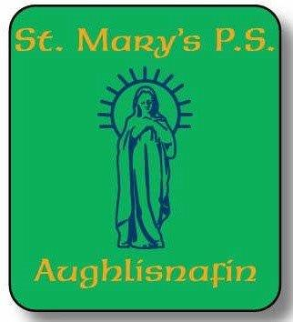

Drop Off and Pick Up.
Dear Parents and Guardians,
The first term is well under way and the children are working hard and continuing on their learning journey.
Mrs Cahill is continuing to welcome new starts to her Reception/P1class.
We are very fortunate to welcome to St Mary’s a new special provision class, Mrs McEvoy’s Early Years and Foundation class. The children in this class are completing their phased introduction this week.
I am mindful, given our duty of care to the children in our school to politely insist that at pick up and drop off, parents, grandparents and child minders make use of the Aughlisnafin Hall Car Park, and walk the children to the school gates.
The reason behind this is to avoid unnecessary congestion at the school gates, in the interest of child safety.
It is understood that the children in Mrs McEvoy’s class will have different arrangements.
Supervised Breakfast club is available from 8am until 8.45am.
The children in Reception up to P7 may dropped off from 8.45 am onward.
Supervision does not begin until 8.45am,either in the yard or in the school building, other than for those attending Breakfast club, as the staff are involved in preparations until that time.

Many thanks for your understanding in this matter,
Kind regards,
Peter Higgins.

