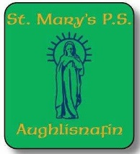

Saint Mary’s Aughlisnafin Extended School Booking Form
Name of pupil(s) ___________________
Week beginning: ____________________
Days requiring breakfast club

Monday | Tuesday | Wednesday | Thursday | Friday

Days requiring after school club

 | Monday | Tuesday | Wednesday | Thursday | Friday
2.45-3.45
(Friday 2.05 – 3.05)

3.45 – 4.45
(Friday 3.05 – 4.05)

